**Task 4 – Operator Precedence Challenge**

**Algorithm**• Evaluate the arithmetic part first: 3 * 2

• Add to 5: 5 + (result)

• Compare with 10: result of 5 + 3 * 2 > 10

• Evaluate equality: 7 == 7

• Apply negation: !(7 == 7)

• Combine both sides with &&

• Display intermediate and final results

**Psudocode**

START

CALCULATE 3 * 2 → result1

CALCULATE 5 + result1 → result2

EVALUATE result2 > 10 → result3

EVALUATE 7 == 7 → result4

EVALUATE !result4 → result5

EVALUATE result3 && result5 → finalResult

DISPLAY all steps and finalResult

END

**Code(javascript)**

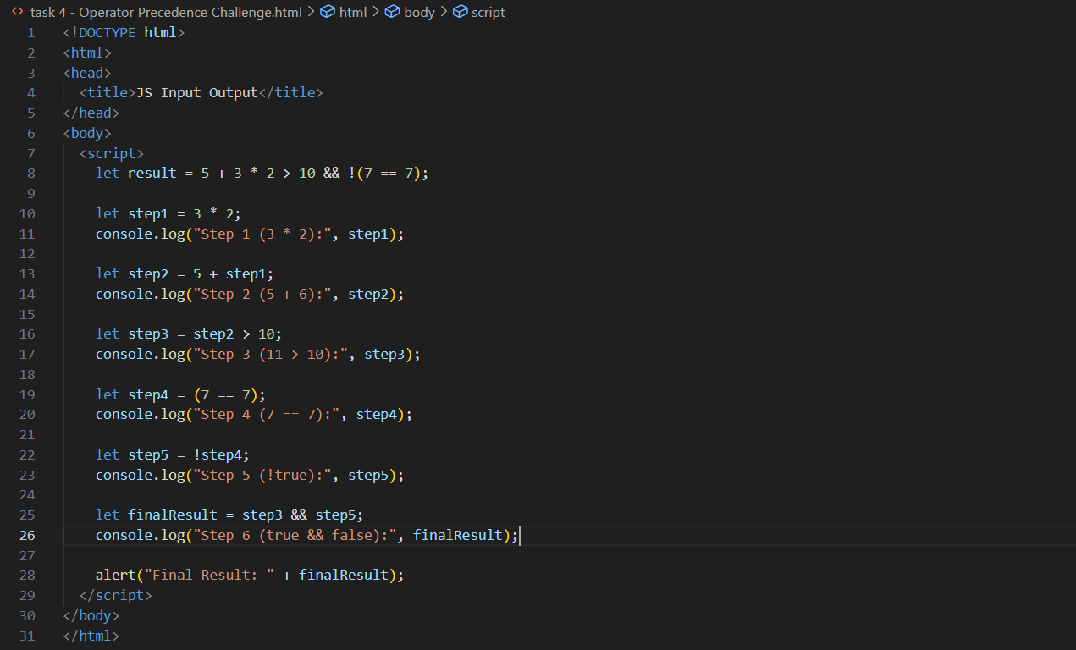

**Output (test case 1)**

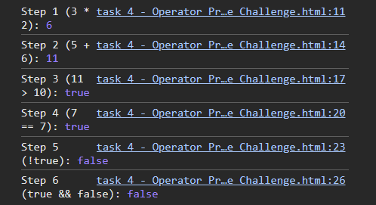

**Observations**

• **Operator precedence** rules are followed strictly: * before +, == before !, and comparisons before &&.

• The left side of && evaluates to true, the right side to false.

• Since true && false is false, the **final result** of the expression is false.

• Step-by-step tracing is useful to understand the **importance of brackets** and evaluation order in complex conditions.